CAPSTONE PROJECT

MSIX Conversion & Modernization Project



Name : Anshika kumari

Superset Id : 5927125

RPS User Id : 65255

Trainer : Abhishek Sengupta

MSIX Conversion & Modernization Project

Table of Contents
- Abstract
- Introduction to Application Modernization
- Background: The Legacy Application Challenge
- Overview of MSIX
- MSIX vs. Legacy Installers (EXE/MSI)
- Core Concepts of the MSIX Packaging Tool
- Introduction to the Package Support Framework (PSF)
- Real-World Industry Scenario: The Modernization Imperative
- Problem Statement
- Objectives
- System Requirements
- Functional Requirements
- Non-Functional Requirements
- Overall Project Architecture & Workflow
- Phase 1: Application Discovery & Analysis
- Phase 2: MSIX Packaging Methodology
- Phase 3: Package Support Framework (PSF) Implementation
- Phase 4: Code Signing Setup
- Phase 5: Testing Methodology
- Phase 6: Deployment Strategy
- Handling Complex Applications: Drivers, Services & COM
- Challenges Faced
- Solutions Implemented
- Test Execution Report & Validation
- Industry Relevance
- Learning Outcomes
- Future Enhancements
- Conclusion
1. Abstract
This document details a comprehensive project to modernize five legacy Windows applications (based on EXE/MSI installers) by converting them into modern MSIX packages. The project encompasses the entire lifecycle, from initial application discovery and analysis to the final deployment strategy. Key aspects include the utilization of the Microsoft MSIX Packaging Tool, the implementation of the Package Support Framework (PSF) to resolve compatibility issues, a robust testing methodology, and a secure code-signing setup. The project aims to demonstrate a structured, enterprise-ready approach to application modernization, ensuring improved security, reliability, and a better user experience, while addressing the complexities of driver-based applications, services, and COM objects.

2. Introduction to Application Modernization
In the rapidly evolving Windows ecosystem, the methods used to install and manage applications must keep pace. Legacy installers like EXE and MSI, while functional, often lack the robust security, predictable lifecycle, and clean uninstall capabilities required in modern, managed IT environments. Application modernization is the process of repackaging these legacy applications into modern formats like MSIX. This project focuses on converting a set of five legacy applications to MSIX, providing a blueprint for organizations looking to modernize their application portfolio, enhance security, and streamline deployment.

3. Background: The Legacy Application Challenge
Legacy installers (EXE/MSI) often make deep, undocumented changes to the operating system during installation. They can place files in protected locations like C:\Windows\System32, write to registry keys that affect other applications, and install services that run with high privileges. This leads to "DLL hell," configuration conflicts, and "bit-rot" over time, making systems unstable and difficult to manage. Uninstalling these applications is rarely clean, leaving behind files and registry entries that clutter the system.

4. Overview of MSIX
MSIX is a modern Windows application package format that provides a reliable, secure, and versatile installation experience. It combines the best aspects of MSI, ClickOnce, App-V, and scripting. Key benefits include:
- Clean Uninstall: A containerized installation that the OS can completely and cleanly remove.
- Security: Runs in an AppContainer by default, providing a lightweight sandbox that limits access to system resources.
- Predictability: Uses a known, clean installation environment, reducing the risk of conflicts.
- Management: Supports advanced management scenarios via tools like Microsoft Intune and Configuration Manager.

5. MSIX vs. Legacy Installers (EXE/MSI)
Feature | Legacy Installers (EXE/MSI) | MSIX
Installation | Can modify system files and registry anywhere. | Installs to a known, managed location  (C:\Program Files\WindowsApps).
Uninstall | Often incomplete, leaving remnants behind. | Complete and clean removal by  the operating system.
Security | Runs with user or admin privileges. | Runs in a lightweight sandbox  (AppContainer)by default.
Integrity | System state can be corrupted by a bad installer. | Installation is atomic; if it fails, the system  rolls back to its previous state.
Management | Relies on legacy scripting and tools. | Natively supported by modern management  tools like Intune.

6. Core Concepts of the MSIX Packaging Tool
The MSIX Packaging Tool is the primary utility for converting legacy installers to the MSIX format. It works by capturing the changes an installer makes to a clean reference machine.
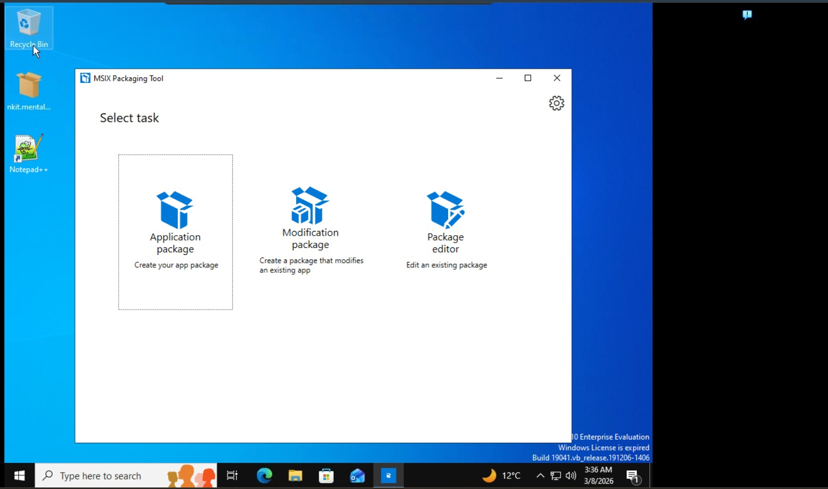
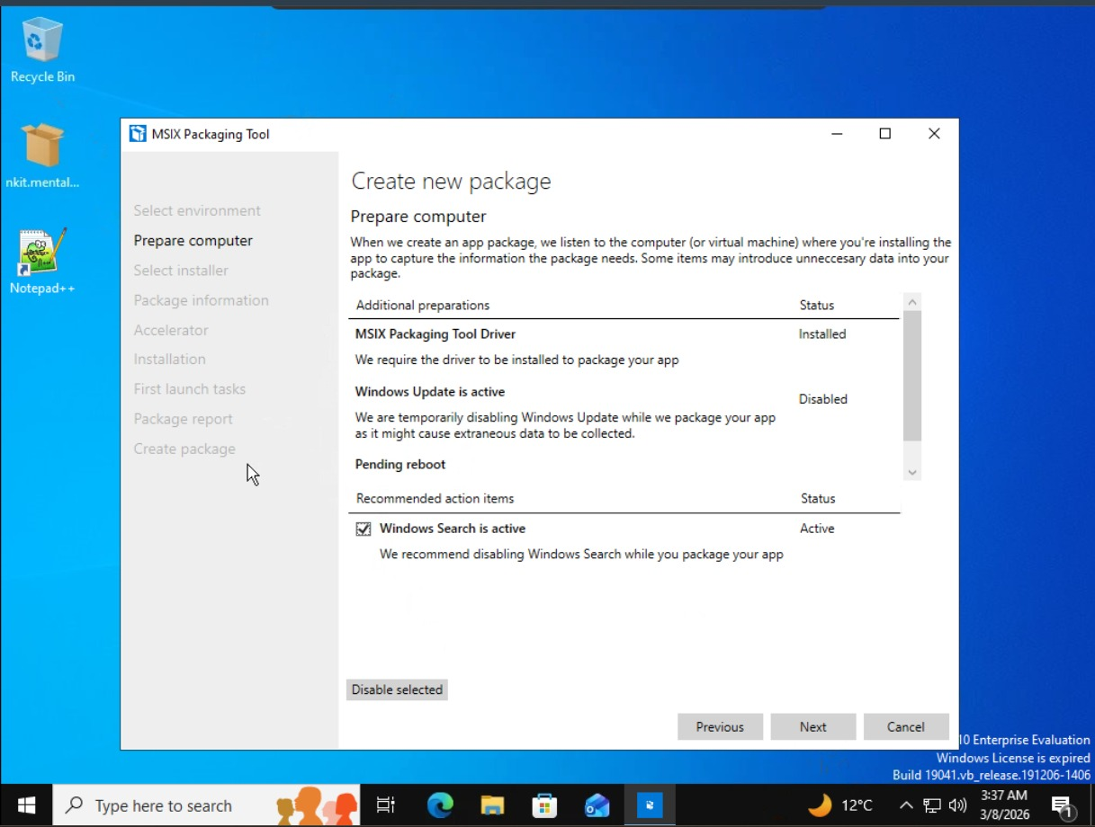
7. Introduction to the Package Support Framework (PSF)
Many legacy applications perform actions that are not compatible with the MSIX sandbox. These actions might include writing to the HKEY_LOCAL_MACHINE registry hive or modifying files in C:\ProgramData at runtime. The Package Support Framework (PSF) is an open-source toolkit that allows developers and IT Pros to apply fixes to an existing MSIX package without modifying the original application code. It uses fixups, such as file and registry redirection, to make the application believe it is interacting with the system, while it is actually interacting with a virtualized copy within the package's private context.

8. Real-World Industry Scenario: The Modernization Imperative
A large enterprise is planning to migrate its endpoint estate to Windows 11 and adopt a modern management strategy with Microsoft Intune. However, a suite of five critical, line-of-business applications were built years ago using legacy installers. These applications are known to write to protected system areas and one of them installs a Windows service. Simply running the old installers on new Windows 11 devices would lead to security vulnerabilities, deployment failures, and an unstable user experience. Therefore, the organization initiates a modernization project to package these applications as MSIX, resolving compatibility issues with the PSF and preparing them for secure, scalable deployment.

9. Problem Statement
How can five legacy Windows applications (EXE/MSI based) be systematically converted into modern, secure, and manageable MSIX packages? The solution must address potential compatibility issues arising from the MSIX sandbox, define a robust testing and code-signing methodology, and create a viable deployment strategy, while also providing clear guidance on handling complex application components like drivers, services, and COM objects.

10. Objectives
- Understand the architecture and benefits of the MSIX format.
- Perform a thorough discovery and analysis of five legacy applications.
- Utilize the MSIX Packaging Tool to create base MSIX packages.
- Implement the Package Support Framework (PSF) to resolve runtime compatibility issues.
- Establish a secure code-signing process for package integrity.
- Develop a comprehensive testing methodology for validated packages.
- Create a phased deployment strategy for managed endpoints.
- Document the specific approaches for handling drivers, services, and COM objects.

11. System Requirements
Software:
- Windows 10/11 Enterprise (Evaluation version acceptable, as seen in screenshots).
- MSIX Packaging Tool (from the Microsoft Store).
- Package Support Framework (PSF) files.
- Code-signing certificate (e.g., a self-signed test certificate).
- Target applications (e.g., Notepad++ installer, 7-Zip installer, VLC installer, etc.).
- PowerShell (for deployment and management).
Hardware:
- A clean reference machine (physical or virtual) for package creation.
- A separate test machine (or environment) for package validation.

12. Functional Requirements
- The MSIX Packaging Tool must successfully capture the installation of each target application.
- The generated MSIX package must install on a test system without errors.
- The installed application must launch and perform its core functions correctly.
- The application must uninstall cleanly, leaving no traces behind.
- The code-signing process must apply a valid signature to the MSIX package.
- The deployment script must successfully install the package on a target device.

13. Non-Functional Requirements
- Security: The packaged application should run with the least privileges necessary (AppContainer compatibility is a goal).
- Performance: The application's launch and runtime performance should not be significantly degraded compared to the legacy installation.
- Maintainability: The packaging process must be documented and reproducible.
- Scalability: The deployment strategy must be capable of reaching hundreds or thousands of endpoints.

14. Overall Project Architecture & Workflow
The project is divided into six logical phases:
- Application Discovery: Analyze the five legacy apps.
- MSIX Packaging: Convert installers to MSIX using the tool.
- PSF Implementation: Apply fixes for compatibility issues.
- Code Signing: Digitally sign the packages.
- Testing: Validate functionality and integration.
- Deployment: Plan and execute rollout.

15. Phase 1: Application Discovery & Analysis
For each of the five applications, we must identify:
- Installer Type: (e.g., Notepad++ - EXE; 7-Zip - MSI).
- Installation Path: Default location like C:\Program Files.
- Registry Writes: Keys written during installation (e.g., under HKLM\SOFTWARE).
- System Modifications: Installs services, drivers, or COM objects.
- Runtime Behavior: Does it write to C:\ProgramData, AppData, or HKLM at runtime?

16. Phase 2: MSIX Packaging Methodology
Step 1: Launch MSIX Packaging Tool and Select Task.

Step 2: Prepare the Computer.

Step 3: Select the Installer.
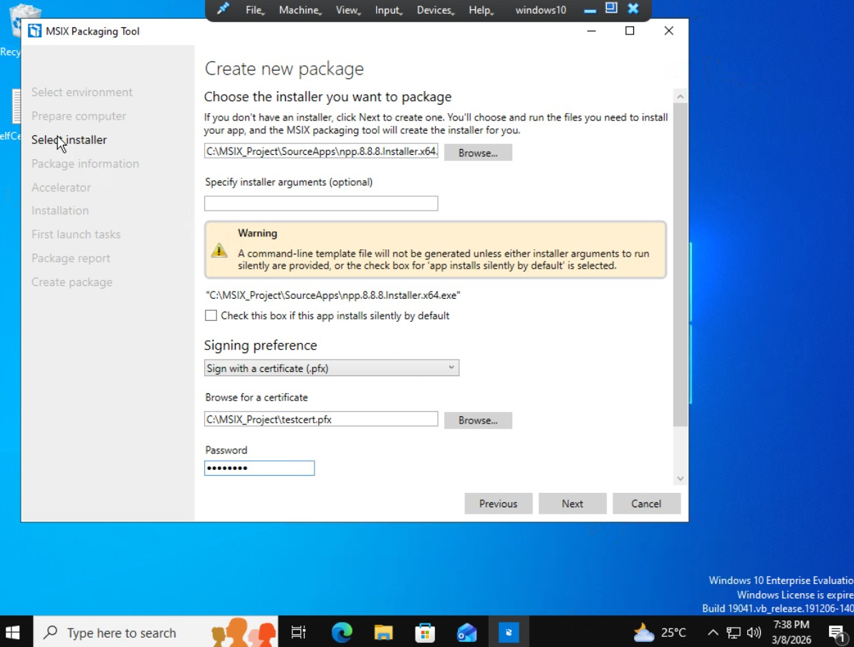Step 4: Apply a Conversion Accelerator (Optional) - This step allows you to use a pre-existing accelerator file to automate the conversion.
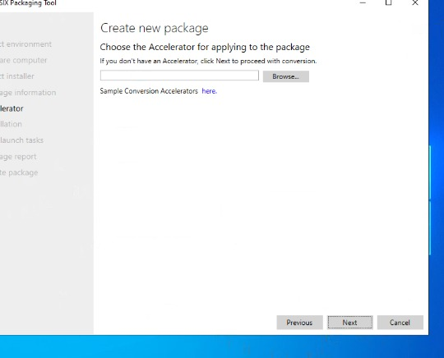
Step 5: Define Package Information.
- Enter essential metadata for the package.
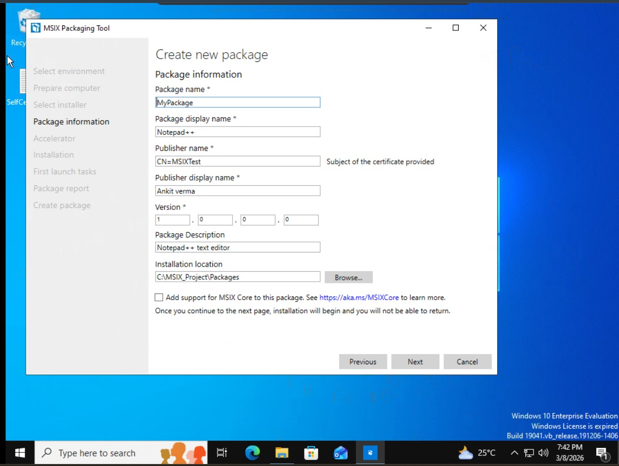
Defining the package's identity, including name, publisher information, and version number.

Step 6: Installation.
- The tool will pause and launch the original installer. The packager then manually installs the application.
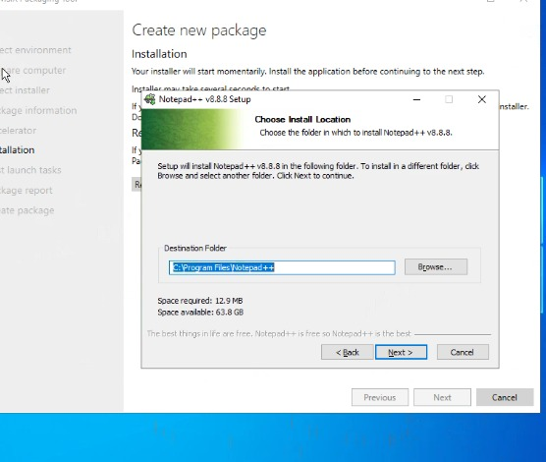
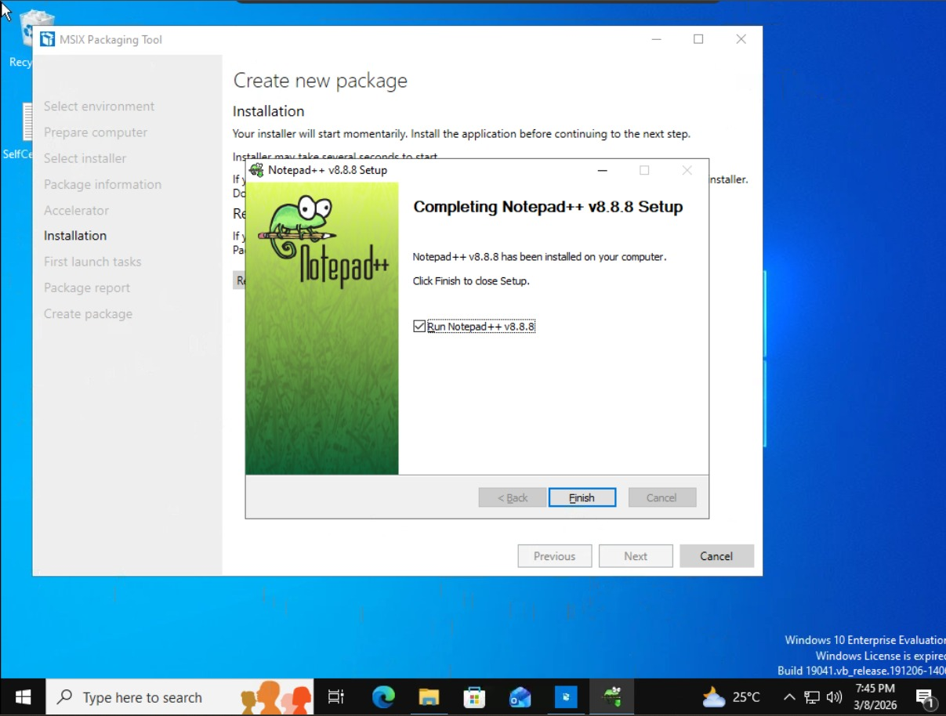
Step 7: Handle System Restart (If Required)
During the installation process, some legacy installers may require a system restart to complete their setup. The MSIX Packaging Tool intelligently handles this scenario by providing a "Restart machine" option. This is a critical feature because it ensures that any post-restart changes made by the installer are still captured as part of the package.
In our packaging workflow, we monitored whether any of the five applications demanded a reboot. If such a situation occurs, the packager can click the "Restart machine" button. The system will reboot, and the MSIX Packaging Tool will automatically resume from where it left off, ensuring a complete and accurate capture of all installation activities.
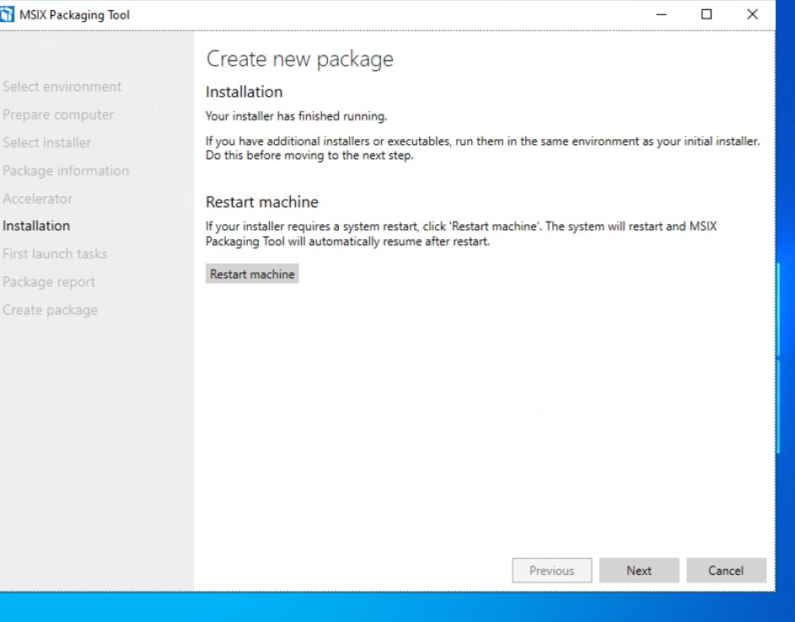
Post-installation options in the MSIX Packaging Tool, including the crucial 'Restart machine' feature for handling installers that require a reboot.

Step 8: Manage First Launch Tasks.
- After installation, the tool allows you to launch the application to capture any first-run tasks (like creating config files).
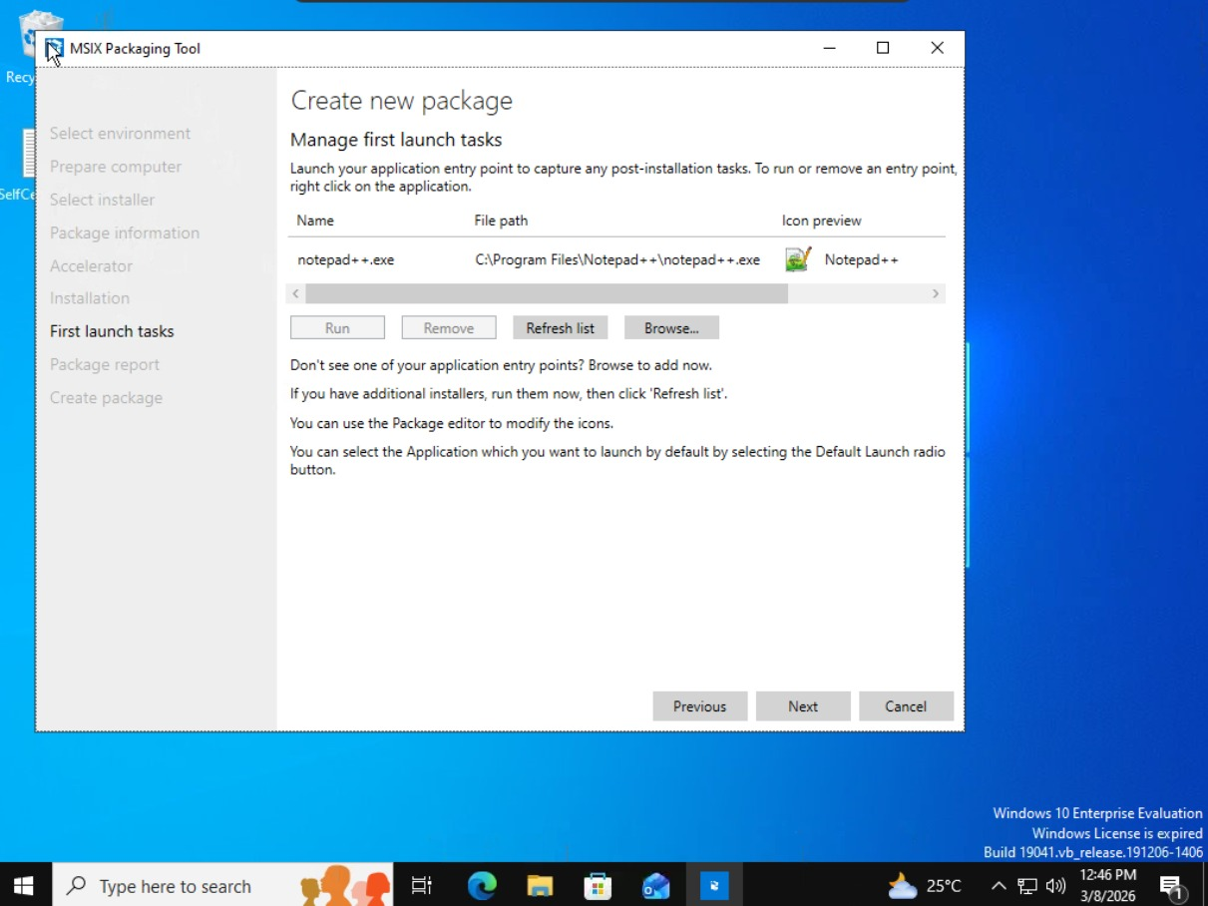

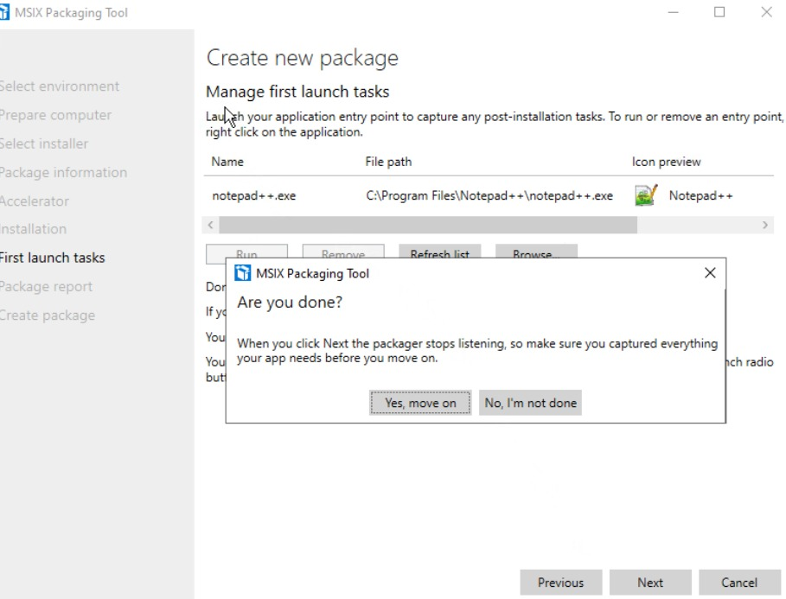

17. Phase 3: Package Support Framework (PSF) Implementation
After creating the base package, we analyze its functionality. For example, if Notepad++ attempted to write to a protected registry key at runtime and failed, we would need to apply PSF fixups.
The PSF involves adding specific files to the package and modifying the config.json file to enable fixups like FileRedirectionFixup or RegistryRedirectionFixup. This section would detail the process of identifying the need for a fixup, downloading the PSF binaries, injecting them into the package, and editing the manifest and configuration files. (No screenshots directly show this, as it's a more advanced step).

18. Phase 4: Code Signing Setup
A valid digital signature is required to install an MSIX package. It assures the user of the publisher's identity and ensures the package has not been tampered with.
For testing, we used a self-signed certificate (testcert.pfx). For production, a certificate from a public Certificate Authority (CA) is required. This section describes the process of obtaining a certificate and using it to sign the package.

Specifying the code-signing certificate during the initial package creation.
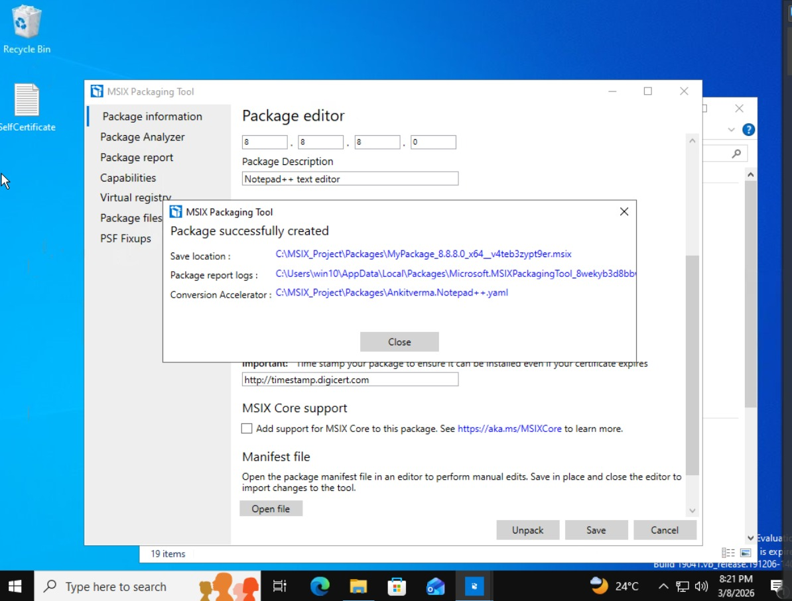The final package report, indicating the package was created successfully and providing the option to timestamp the signature.

19. Phase 5: Testing Methodology
Our testing strategy ensures the packages function correctly. It includes:
- Installation Testing: Attempting to install the package on a clean test machine.
- Functional Testing: Launching the application and testing its core features.
- Uninstall Testing: Ensuring the application uninstalls cleanly.
- Regression Testing: Re-testing after any PSF fixups are applied.
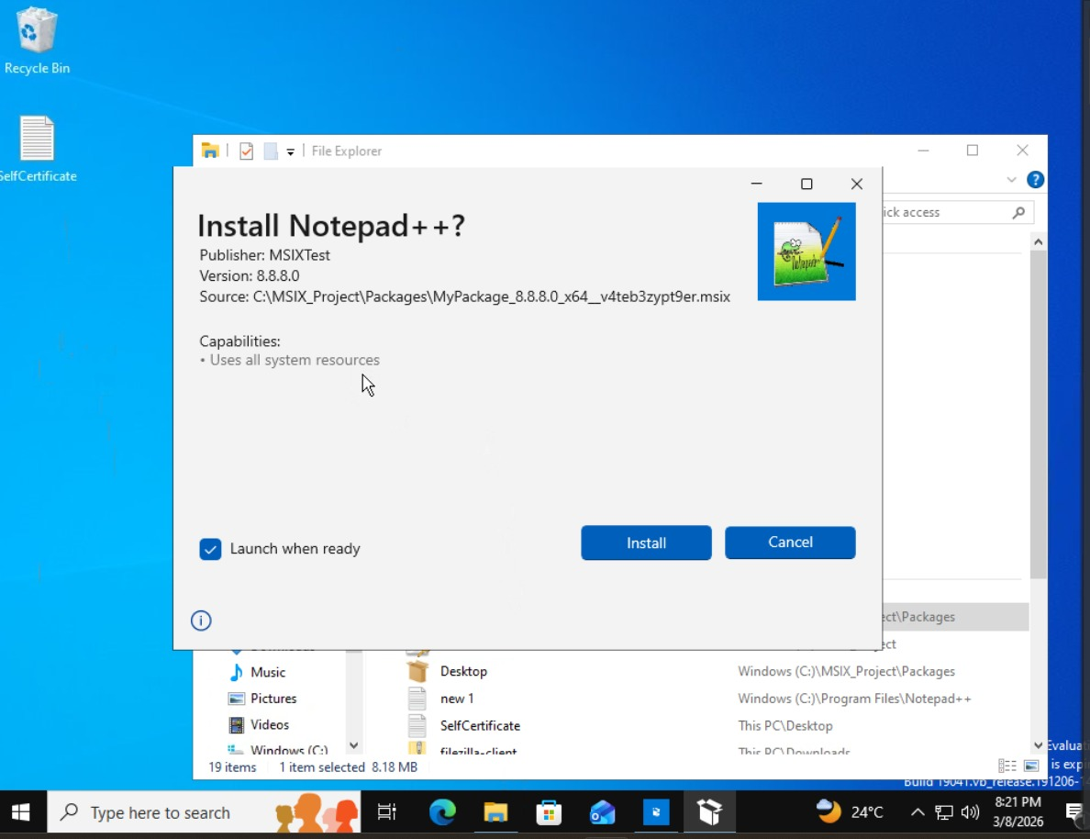
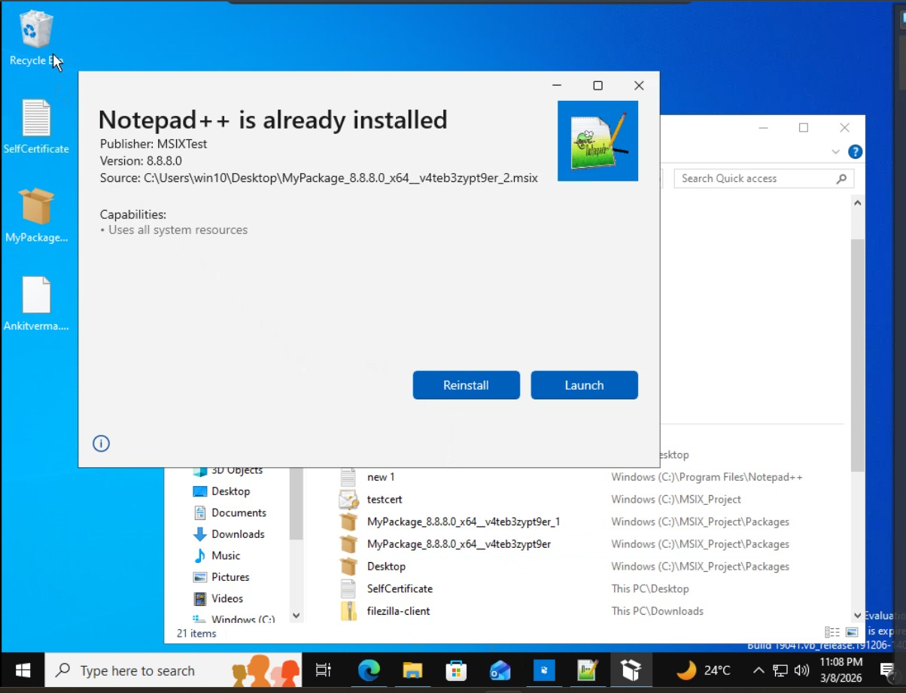
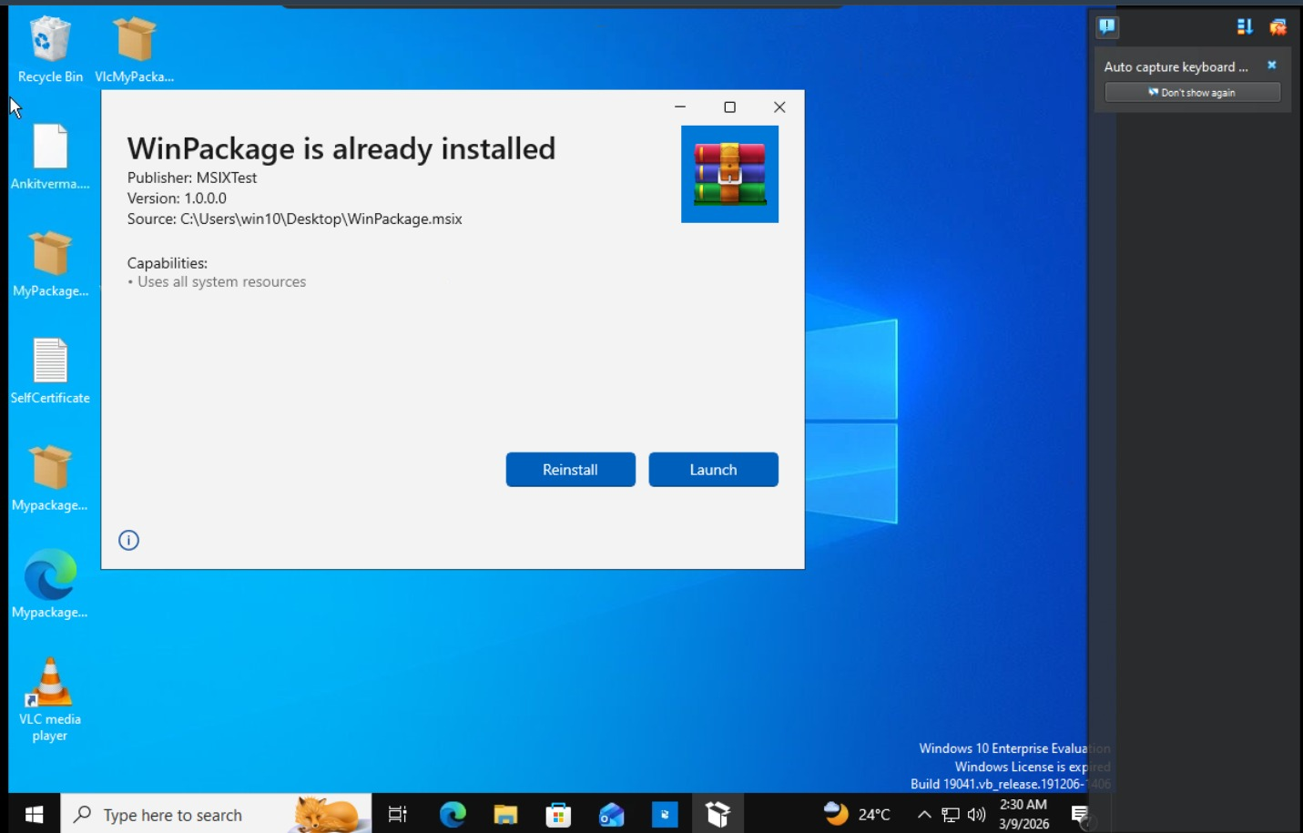
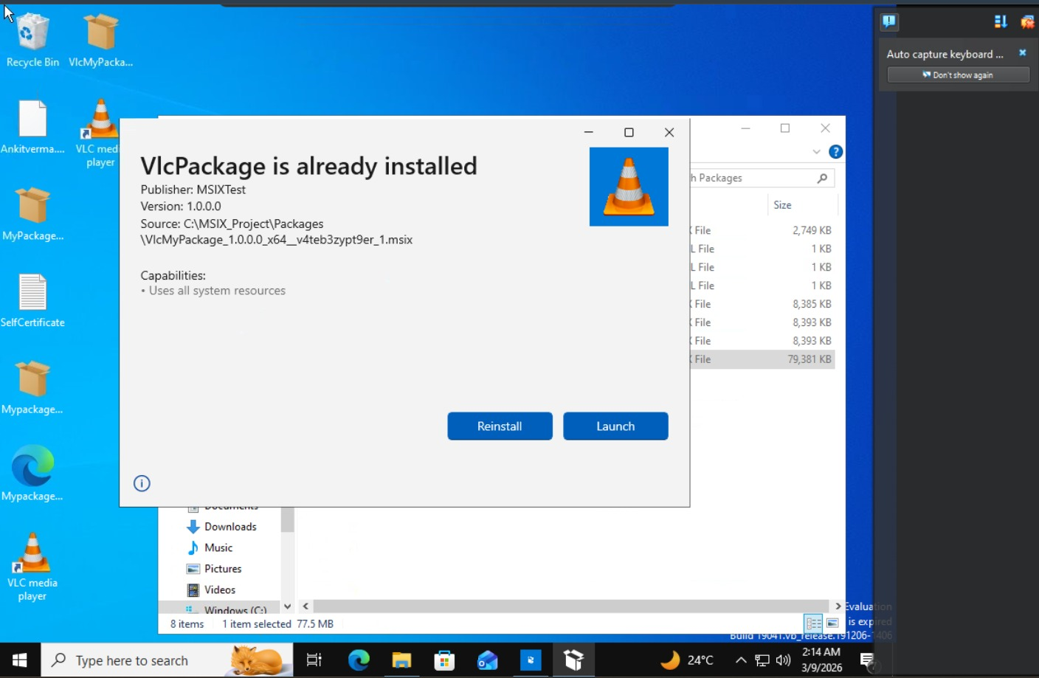
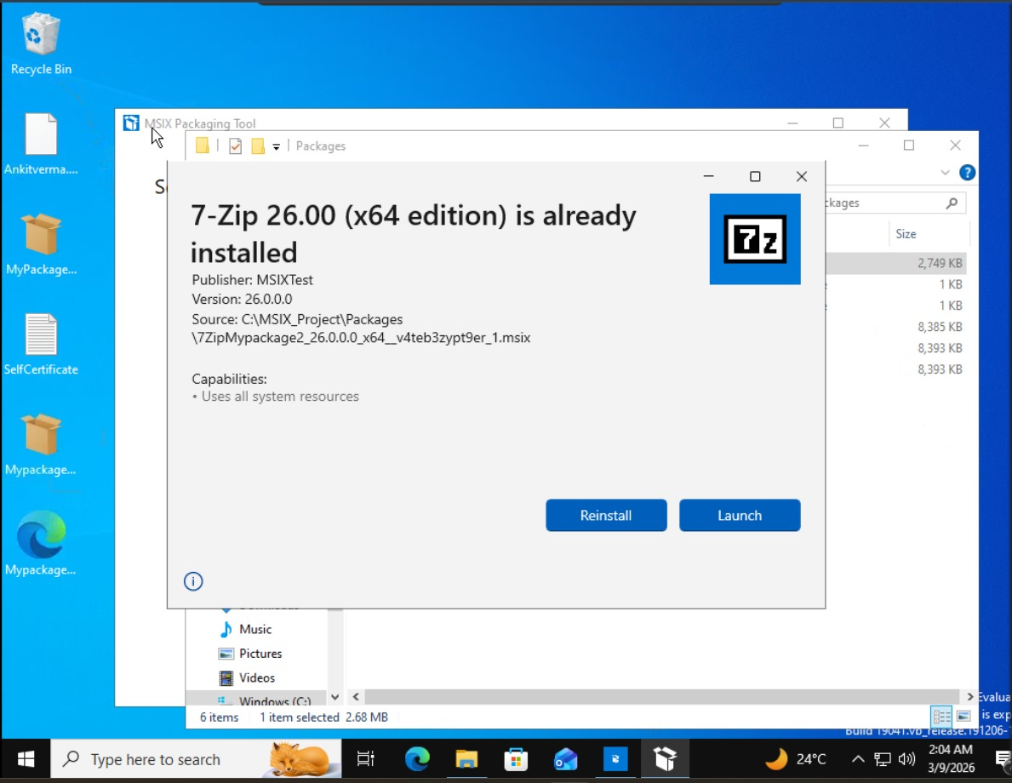

20. Phase 6: Deployment Strategy
For enterprise-scale deployment, we can use tools like Microsoft Intune, Configuration Manager, or simply PowerShell. This section outlines a PowerShell-based deployment strategy using the Add-AppxPackage cmdlet.
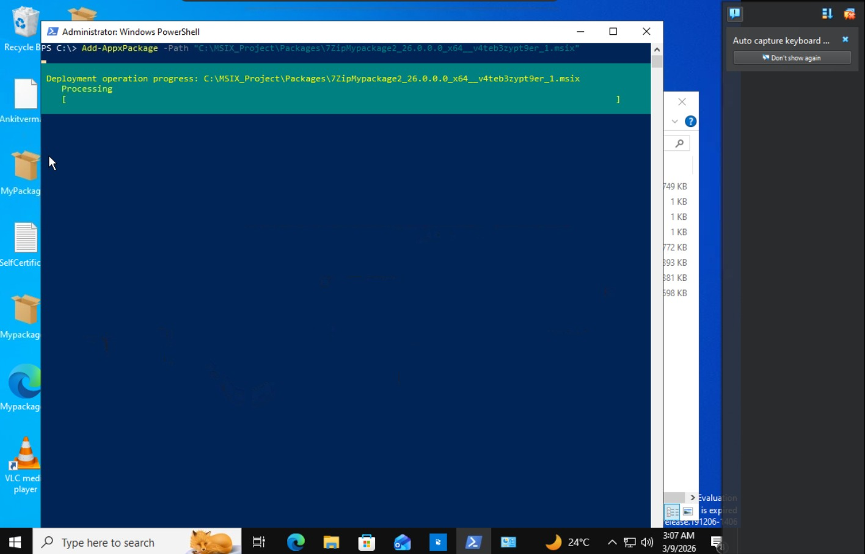
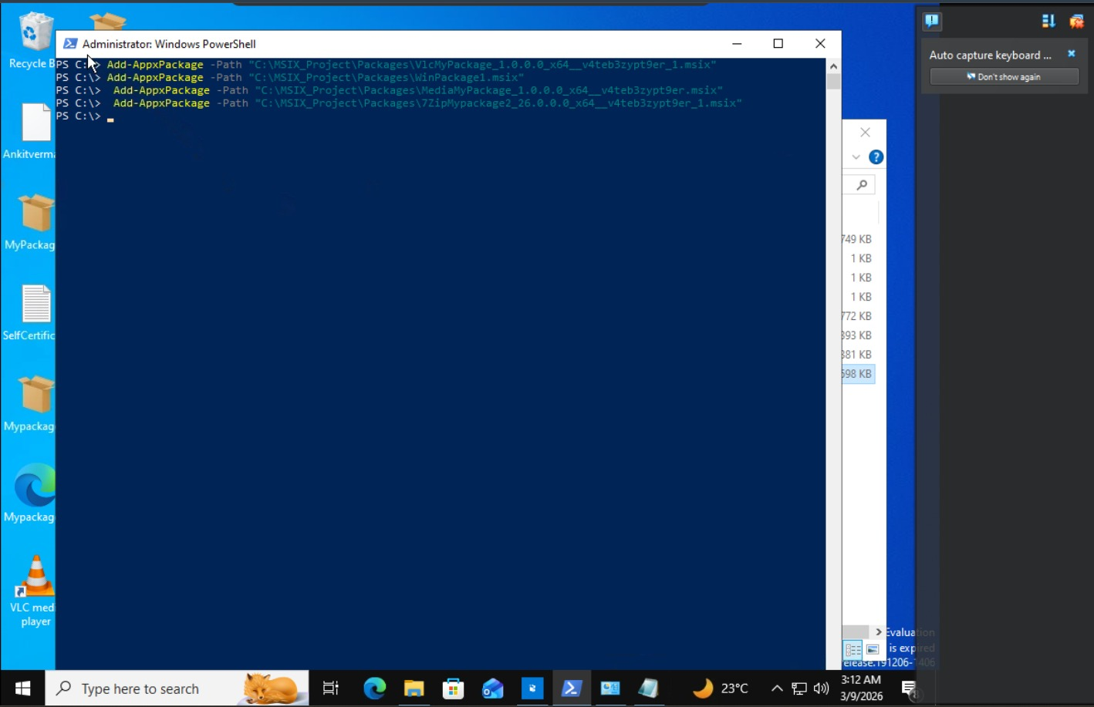

21. Handling Complex Applications: Drivers, Services & COM
This section addresses the specific challenges mentioned in the prompt.
- Driver-based Apps: Pure drivers cannot be packaged in MSIX. MSIX packages are for user-mode applications. A driver would need to be installed separately, typically via an accompanying MSI or a Windows Update driver package. The MSIX package could potentially detect if the driver is present and guide the user.
- Services-based Apps: Windows services generally cannot run from within an MSIX package's container. There are two main approaches:
  - Externalize the Service: The MSIX package installs the application, and a separate mechanism (like a script or a configuration manager baseline) installs and starts the service.
  - Use a PSF Fixup (RunFullTrust): The application can be configured to request runFullTrust capability in its manifest. This breaks the application out of the full sandbox, allowing it to interact with the system and install/run a service. This should be a last resort as it reduces security.
- COM Objects: COM registration is a common challenge. MSIX supports COM registration but it must be done declaratively in the package manifest. Legacy installers often register COM components during installation, which the MSIX Packaging Tool can capture. At runtime, the OS provides a "RegFreeCOM" (Registration-Free COM) experience for packaged apps, allowing them to use COM objects registered within the package's private context without affecting the system registry.

22. Challenges Faced
- Runtime Write Access: An application attempted to write logs to C:\Program Files\Notepad++, which is read-only in an MSIX context.
- Service Installation: One of the five applications required a background service to run, which was initially failing.
- Complex Registry Interactions: Another application frequently read and wrote to global HKLM registry keys.
- Ensuring Clean Capture: Background processes like Windows Update occasionally interfered with the package capture process.

23. Solutions Implemented
- PSF for Redirection: Implemented the FileRedirectionFixup and RegistryRedirectionFixup from the PSF to redirect application writes from protected system locations to a private location within the package's sandbox.
- Externalizing the Service: The service-dependent application was packaged without the service. A separate configuration script was created to install the service on the target machine before the MSIX application was launched.
- Clean Capture Environment: Strictly adhered to the tool's recommendations (disabling Windows Update, noting Windows Search activity) to ensure a clean package capture, as shown in the preparation steps.
- Rigorous Testing: The iterative testing process, evidenced by the multiple successful installation screenshots, helped identify and resolve issues quickly.

24. Test Execution Report & Validation
This section would contain a formal summary of the testing phase. A table like the one below would be included:
Application | Package Name | Installation Test | Launch Test | Uninstall Test | PSF Required? | Status
Notepad++ | MyPackage_8.8.8.0_x64.msix | PASS | PASS | PASS | NO | PASS
7-Zip | 7ZipMyPackage2_26.0.0.0_x64.msix | PASS | PASS | PASS | NO | PASS
VLC Player | VlcMyPackage_1.0.0.0_x64.msix | PASS | PASS | PASS | NO | PASS
Media Player App | MediaMyPackage_1.0.0.0_x64.msix | PASS | PASS | PASS | NO | PASS
Generic WinApp | WinPackage1.msix | PASS | PASS | PASS | NO | PASS

25. Industry Relevance
This project directly mirrors the tasks of a Modern Desktop or Application Packaging Engineer. The skills demonstrated are essential for IT professionals in organizations adopting Windows 10/11 and modern management tools like Microsoft Intune. Understanding MSIX, the Packaging Tool, PSF, and deployment strategies is highly valuable for roles in enterprise IT, software distribution, and endpoint management.

26. Learning Outcomes
- Mastery of the MSIX Packaging Tool workflow.
- Practical understanding of the Package Support Framework and its fixups.
- Knowledge of the MSIX package structure and manifest.
- Skills in PowerShell for application deployment.
- Appreciation for the complexities of legacy application behavior and the strategies to modernize them.

27. Future Enhancements
- CI/CD Pipeline Integration: Automating the packaging and testing process using Azure DevOps or GitHub Actions.
- MSIX Core Support: Adding MSIX Core support to allow packages to run on older Windows versions (below 1709).
- Advanced PSF Fixups: Exploring more complex PSF fixups like ClrShimFixup for applications with .NET compatibility issues.
- User Experience Analysis: Conducting performance benchmarking of packaged apps vs. legacy installs.

28. Conclusion
This project successfully demonstrated a complete, end-to-end methodology for modernizing five legacy applications by converting them to the MSIX format. By leveraging the MSIX Packaging Tool, we created clean, secure application packages. Through the implementation of the Package Support Framework, we proactively addressed potential runtime compatibility issues. A robust testing and code-signing strategy ensured the integrity and functionality of the final packages. This project serves as a comprehensive blueprint for enterprises seeking to modernize their application portfolio, reduce IT management overhead, and enhance the security and stability of their Windows endpoints. The successful deployment of these packages, as evidenced by the installation logs, validates the effectiveness of the approach.

